**Create EKS Management Host in AWS**Create a new EC2 Instance: EKS-Management-HostEKS (Elastic Kubernetes Service) is a managed Kubernetes service provided by AWS. It simplifies the process of deploying and managing Kubernetes clusters in the cloud.  
Prerequisites:  
--- An existing VPC and subnets that meet Amazon EKS requirements.  
--- The kubectl command line tool is installed on your device or AWS CloudShell  
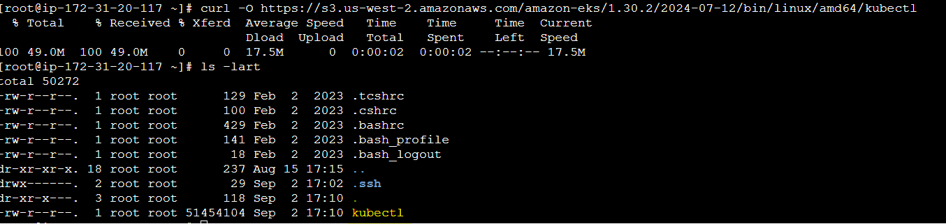  
kubectl is a binary which is created so we need to give it execute permission  
chmod +x kubectl  
Move it to usr/local/bin path so that we can execute the command from anywhere  
mv kubectl /usr/local/bin/  
--- Version 2.12.3 or later or version 1.27.160 or later of the AWS Command Line Interface (AWS CLI) installed